Initial Public Offer Investment Strategy Utilizing Hierarchical Multi-Agent Artificial Intelligence System

Aman Jain
School of Engineering and Technology (SOET)
BML Munjal University
Gurugram, India
aman.jain.23cse@bmu.edu.in

Rohit Fogla
School of Engineering and Technology (SOET)
BML Munjal University
Gurugram, India
rohit.fogla23cse@bmu.edu.in

Abstract— The growing uncertainty and non-linear dynamics of modern financial markets have challenged the effectiveness of conventional forecasting techniques in guiding investment decisions. Thus, this study proposes an multi agentic artificial intelligence framework that integrates multiple autonomous agents to enhance decision-making efficiency in complex market environments. The framework is designed as a hierarchical multi-agent system wherein specialized agents collaboratively process heterogeneous financial information, including price movements, macroeconomic indicators, investor sentiment, and risk signals. This study employs large language models and real-time data streams. The system comprises six distinct functional agents which suggest investment and exit strategy for IPOs. The proposed framework addresses critical factors or retail investment decision making. The results indicate that the multi-agent architecture significantly improves forecasting precision and decision robustness, achieving higher confidence levels up to 80% and better portfolio outcomes compared to traditional single-model approaches. Furthermore, the framework demonstrates enhanced capability in identifying market anomalies, managing downside risks, and optimizing asset allocation strategies. The study contributes to the evolving discourse on intelligent financial systems by introducing a scalable and adaptive AI-driven investment ecosystem. It offers valuable insights for investors, financial institutions, and policymakers seeking to leverage autonomous decision systems for improved market efficiency, informed investment strategies, and resilient risk management in increasingly complex financial landscapes.

Introduction
Financial markets have experienced rapid transformation in recent years due to technological advancements, digital trading platforms, and increasing participation of retail investors. Among various investment opportunities, Initial Public Offerings (IPOs) have emerged as one of the most attractive yet highly volatile financial instruments. IPOs provide investors with an opportunity to invest in companies during their transition from private to public ownership, often generating substantial returns within a short duration. However, IPO investments involve significant uncertainty because their performance is influenced by multiple interconnected factors such as market sentiment, institutional investor behavior, macroeconomic conditions, subscription trends, company fundamentals, and speculative market activities. Traditional IPO evaluation methods mainly rely on manual financial analysis, historical comparisons, and subscription statistics, which are often insufficient for handling the dynamic and multidimensional nature of modern financial markets.
The emergence of Artificial Intelligence (AI), Machine Learning (ML), Natural Language Processing (NLP), and Large Language Models (LLMs) has created new opportunities for intelligent financial forecasting and investment decision-making systems. AI-driven frameworks can process large volumes of structured and unstructured financial data, identify hidden market patterns, and generate predictive insights with greater speed and accuracy. In recent years, Multi-Agent Systems (MAS) have gained significant importance in financial technology because they enable multiple autonomous agents to collaboratively analyze different dimensions of complex financial problems. Unlike traditional single-model approaches, multi-agent architectures provide better adaptability, modularity, parallel processing capability, and explainability, making them highly suitable for real-time financial analysis and investment strategy generation.
To address the limitations of conventional IPO prediction systems, this project proposes “SarthakNivesh”, a Hierarchical Multi-Agent Artificial Intelligence Framework designed for IPO investment analysis and decision support. The framework integrates six specialized intelligent agents, namely the Price Movement Agent, Macroeconomic Agent, Sentiment Agent, Risk Assessment Agent, IPO Intelligence Agent, and Master Orchestrator Agent. Each agent independently analyzes a specific aspect of the financial ecosystem using domain-specific methodologies. The system combines technical analysis, macroeconomic indicators, institutional investor activity, news sentiment analysis, grey market premium trends, and risk evaluation to generate comprehensive investment recommendations. Advanced NLP techniques and Large Language Models such as Groq Llama 3.3 70B are utilized to process financial news articles and generate explainable investment insights, thereby improving transparency and investor understanding.
The proposed framework utilizes real-time financial data streams, machine learning algorithms, sentiment analysis techniques, and hierarchical decision-making strategies to improve forecasting precision and investment confidence. A comprehensive backtesting environment was developed using real IPO data from the Indian stock market to evaluate the effectiveness of the framework. Experimental results demonstrated improved prediction accuracy, enhanced confidence levels, superior portfolio performance, and better risk management compared to traditional investment approaches. The project contributes significantly to the field of AI-driven financial systems by introducing a scalable, adaptive, and explainable multi-agent investment ecosystem capable of supporting intelligent financial decision-making for retail investors, financial analysts, and investment institutions.

Literature Review
The field of financial forecasting and IPO investment analysis has evolved significantly with the advancement of Artificial Intelligence, Machine Learning, Natural Language Processing, and intelligent decision-support systems. Early foundational studies on IPO performance mainly focused on understanding IPO underpricing, investor behavior, and post-listing market performance using traditional statistical and econometric techniques. Ritter (1991), in his foundational work on IPO underpricing, explained that newly listed companies often experience abnormal initial returns due to market speculation and information asymmetry. Similarly, Ljungqvist and Wilhelm analyzed the role of institutional investor participation and demonstrated that higher Qualified Institutional Buyer (QIB) subscription generally indicates stronger investor confidence and improved IPO performance. Although these studies established important financial theories related to IPO markets, they lacked the capability to process real-time financial information and adapt to rapidly changing market environments.
With the emergence of Machine Learning and computational intelligence techniques, researchers began applying predictive models such as Decision Trees, Support Vector Machines, Random Forests, and Neural Networks for stock market and financial forecasting tasks. Chen et al. proposed ensemble learning approaches capable of improving prediction robustness and reducing forecasting errors by combining multiple machine learning models. Later, deep learning techniques such as Long Short-Term Memory (LSTM) networks gained popularity due to their ability to capture sequential dependencies and temporal market patterns in financial time-series data. Fischer and Krauss demonstrated that LSTM-based architectures significantly improved stock market prediction performance compared to traditional statistical approaches. However, most of these models primarily focused on quantitative financial indicators and often lacked interpretability and contextual understanding of market behavior.
The introduction of Natural Language Processing (NLP) and sentiment analysis further enhanced financial forecasting systems by incorporating qualitative market intelligence into predictive models. Bollen, Mao, and Zeng demonstrated that investor sentiment extracted from social media and financial news exhibits strong correlation with stock market movement. Sentiment analysis tools such as VADER and TextBlob became widely adopted for extracting positive, negative, and neutral investor sentiment from textual financial data. However, traditional sentiment analysis approaches struggled with contextual understanding of financial language and often failed to capture deeper semantic relationships within financial news articles. The development of transformer-based language models such as BERT and Large Language Models significantly improved contextual interpretation and semantic understanding in NLP tasks. These advancements enabled more sophisticated analysis of investor perception, financial sentiment, and qualitative market signals.
The concept of Multi-Agent Systems (MAS) introduced distributed intelligence and collaborative decision-making into financial technology applications. Wooldridge and Jennings established the theoretical foundation for intelligent agent systems by defining characteristics such as autonomy, proactiveness, reactivity, and social interaction among agents. Multi-agent architectures have since been applied in various domains including algorithmic trading, portfolio management, fraud detection, and financial simulation due to their scalability, modularity, and parallel processing capability. However, most existing multi-agent financial systems focused on general stock trading and portfolio optimization rather than IPO-specific investment analysis. Additionally, limited research has explored the integration of hierarchical multi-agent systems with Large Language Models for explainable IPO investment recommendation generation.
To address these research gaps, the proposed SarthakNivesh framework introduces a Hierarchical Multi-Agent Artificial Intelligence ecosystem capable of integrating technical analysis, macroeconomic reasoning, investor sentiment analysis, institutional intelligence, and risk-aware forecasting into a unified and explainable decision-support framework. The proposed system combines multiple specialized analytical agents with Large Language Models to improve prediction accuracy, investment confidence, portfolio profitability, and interpretability within IPO investment analysis. By integrating both quantitative financial indicators and qualitative market intelligence, the framework contributes toward the development of scalable, adaptive, and intelligent AI-driven financial forecasting systems for modern investment ecosystems.

Methodology

Proposed Framework Overview
The proposed framework, SarthakNivesh, is designed as a hierarchical multi-agent artificial intelligence system for IPO investment analysis and decision support. The framework integrates Artificial Intelligence (AI), Machine Learning (ML), Natural Language Processing (NLP), Large Language Models (LLMs), and financial forecasting techniques to analyze multiple dimensions of IPO performance. The methodology is specifically developed to overcome the limitations of traditional IPO evaluation methods, which generally fail to process heterogeneous financial information in real time and often rely on isolated analytical approaches.
The overall system operates through a layered workflow consisting of data collection, preprocessing, multi-agent analysis, orchestration, recommendation generation, deployment, and backtesting evaluation. Multiple autonomous agents independently analyze technical indicators, macroeconomic conditions, investor sentiment, institutional behavior, and investment risk. The outputs generated by these agents are aggregated using a centralized orchestrator mechanism to generate final investment recommendations and confidence scores. The modular architecture enables parallel analytical processing, scalability, adaptability, and interpretability within the investment decision-making process.
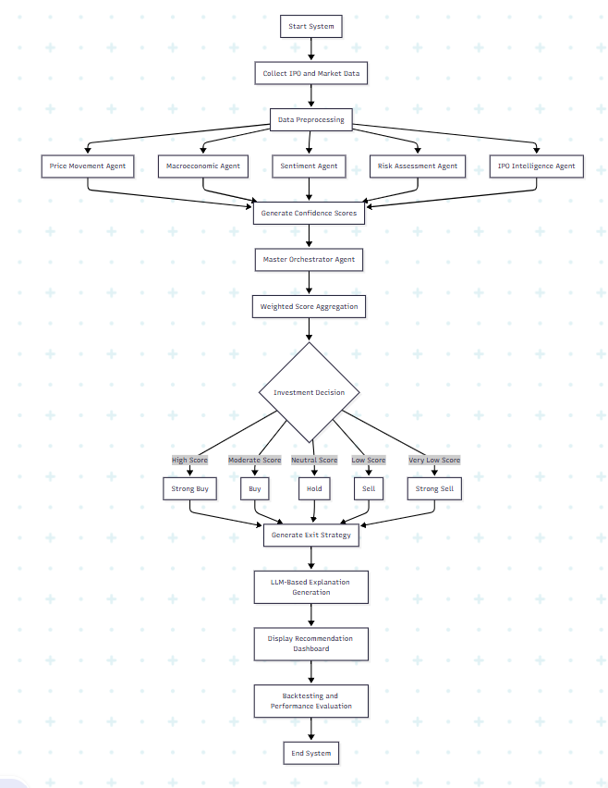Fig – A methodology flowchart

Data Collection and Data Preprocessing
The first stage of the methodology involves collecting structured and unstructured financial data from multiple sources. IPO-specific information including issue price, listing price, issue size, subscription details, Qualified Institutional Buyer (QIB) participation, retail subscription, and grey market premium is collected from financial databases, NSE platforms, IPO websites, and market APIs. Historical stock prices, NIFTY index values, trading volumes, and sectoral performance indicators are collected using Yahoo Finance APIs and other financial market services.
To integrate qualitative market intelligence into the framework, financial news articles and market updates are extracted from sources such as Economic Times, Moneycontrol, and Google News. Since the collected information originates from heterogeneous sources and formats, preprocessing operations are performed to improve consistency and analytical quality. Numerical data preprocessing includes handling missing values, duplicate removal, normalization, feature engineering, and standardization of financial indicators. Textual data preprocessing involves text cleaning, tokenization, stop-word removal, stemming, and sentiment keyword extraction using NLP techniques.
For market trend analysis, percentage change calculations are performed using the following formula:
Percentage\ Change = \frac{Current\ Value - Previous\ Value}{Previous\ Value} \times 100
Similarly, stock return calculations are computed using:
Return = \frac{Closing\ Price - Opening\ Price}{Opening\ Price} \times 100
These engineered features are further utilized by the analytical agents for market prediction and investment analysis.

Hierarchical Multi-Agent Analytical System
The core component of the proposed framework is the hierarchical multi-agent analytical system consisting of six specialized intelligent agents. Each agent independently evaluates a specific dimension of the IPO ecosystem and generates a normalized confidence score representing the investment attractiveness of the IPO.
The Price Movement Agent analyzes technical indicators, historical subscription trends, listing gain probabilities, moving averages, and market momentum patterns. Technical indicators are calculated using moving average formulas such as:
SMA = \frac{P_1 + P_2 + P_3 + ... + P_n}{n}
where (P_n) represents stock prices over a defined time window.
The Macroeconomic Agent evaluates broader economic conditions including NIFTY trends, sectoral growth, inflation indicators, and institutional fund flows. Market momentum analysis is performed using index trend computations and rolling average calculations to identify bullish or bearish market conditions affecting IPO performance.
The Sentiment Agent utilizes Natural Language Processing techniques, VADER sentiment analysis, TextBlob analysis, and Large Language Models to process financial news articles and investor opinions. Sentiment polarity is calculated using sentiment scoring mechanisms represented as:
Sentiment\ Score = Positive\ Score - Negative\ Score
The use of Large Language Models improves contextual understanding of financial language and enables accurate extraction of investor sentiment from unstructured textual data.
The Risk Assessment Agent evaluates downside exposure, market uncertainty, and investment volatility associated with IPO investments. Volatility calculations are performed using standard deviation measures:
\sigma = \sqrt{\frac{\sum (x_i - \mu)^2}{N}}
where ( \sigma ) represents volatility, (x_i) represents market observations, and ( \mu ) represents the mean market return.
The IPO Intelligence Agent studies specialized IPO-related indicators including QIB participation, grey market premium trends, peer comparison, and valuation analysis to identify institutional confidence and investment attractiveness.

Orchestration and Decision-Making Mechanism
After analytical processing by individual agents, the generated confidence scores are forwarded to the Master Orchestrator Agent, which acts as the central decision-making component of the framework. The orchestrator combines outputs from all agents using weighted aggregation techniques to generate a unified investment recommendation.
The final confidence score is calculated using weighted averaging:
Final\ Score = \sum_{i=1}^{n} w_i \times s_i
where (w_i) represents the weight assigned to each agent and (s_i) represents the confidence score generated by the respective agent.
Based on the final confidence score, the framework categorizes recommendations into Strong Buy, Buy, Hold, Sell, or Strong Sell classes. Large Language Models such as Groq Llama 3.3 70B are integrated to generate human-readable investment explanations, thereby improving interpretability and transparency of the AI-driven recommendation process.

System Deployment and Implementation Environment
The proposed framework is implemented using Python due to its extensive ecosystem for machine learning, financial analytics, and artificial intelligence development. Libraries such as Pandas, NumPy, Scikit-learn, yFinance, TextBlob, VADER, Matplotlib, and Requests are utilized for data analysis, financial forecasting, visualization, and sentiment processing. Groq API services are integrated to access Large Language Models for contextual financial analysis and explanation generation.
The deployment architecture follows a modular layered design where analytical agents operate independently while communicating with the centralized orchestrator component. The backend system supports asynchronous execution and parallel processing of agents to improve analytical efficiency and reduce computational latency. Real-time financial data is dynamically processed to generate updated investment recommendations and confidence scores.
The framework can be deployed through a web-based dashboard or cloud-enabled environment to provide accessibility for investors and analysts. Visualization tools are integrated to display sentiment trends, IPO performance graphs, confidence scores, and backtesting results in an interpretable format. The modular deployment strategy also supports future integration of automated trading systems, cloud infrastructure, and mobile financial applications.

F. Backtesting and Performance Evaluation
To validate the effectiveness of the proposed framework, a comprehensive backtesting methodology is implemented using historical IPO data from the Indian stock market spanning from 2021 to 2024. The generated recommendations are compared with actual IPO listing outcomes to evaluate forecasting accuracy and investment profitability.
Performance evaluation is conducted using metrics such as prediction accuracy, portfolio return, confidence score evaluation, volatility analysis, and risk-adjusted return measures. Portfolio return is calculated using:
Portfolio\ Return = \frac{Final\ Portfolio\ Value - Initial\ Investment}{Initial\ Investment} \times 100
Experimental analysis demonstrates that the hierarchical multi-agent framework significantly improves forecasting precision, investment confidence, and portfolio performance compared to conventional IPO evaluation methods and traditional single-model approaches. The framework also demonstrates enhanced capability in risk management, sentiment interpretation, and adaptive decision-making under changing market conditions.

RESULTS AND ANALYSIS

A. Experimental Evaluation Overview
The proposed framework, SarthakNivesh, was evaluated using historical IPO data from the Indian stock market covering the period from 2021 to 2024. The experimental validation was conducted through the implementation of the IPO_Backtesting.ipynb notebook, which simulated real-world IPO investment scenarios and analyzed the effectiveness of the hierarchical multi-agent architecture under varying market conditions. The evaluation process focused on measuring prediction accuracy, portfolio profitability, confidence score generation, volatility management, and overall investment decision quality.
The backtesting environment integrated multiple financial indicators including IPO subscription data, listing gains, institutional investor participation, market trends, sectoral performance, and sentiment analysis extracted from financial news sources. Each specialized intelligent agent independently analyzed its assigned financial dimension and generated confidence scores that were aggregated by the Master Orchestrator Agent to produce final investment recommendations. The recommendations generated by the framework were then compared with actual IPO market outcomes to evaluate forecasting precision and portfolio performance.

B. Dataset and Experimental Parameters
The experimental dataset consisted of IPOs listed on the Indian stock market between 2021 and 2024. The framework processed both structured and unstructured financial information including technical indicators, macroeconomic conditions, institutional participation, and investor sentiment data.

Table 6.1 Dataset and Experimental Configuration
Parameter | Description
Market Domain | Indian IPO Market
Evaluation Period | 2021 – 2024
Data Sources | NSE, Yahoo Finance, IPO Databases, Financial News
Analysis Type | Multi-Agent Financial Forecasting
Sentiment Sources | Economic Times, Moneycontrol, Google News
NLP Techniques | VADER, TextBlob, LLM-Based Sentiment Analysis
Large Language Model | Groq Llama 3.3 70B
Development Environment | Python, Jupyter Notebook
Backtesting Platform | IPO_Backtesting.ipynb
Performance Metrics | Accuracy, Portfolio Return, Volatility, Confidence Score
The collected data was preprocessed using normalization, feature engineering, and sentiment extraction techniques before being distributed among the analytical agents. The experimental environment was designed to ensure reproducibility and realistic simulation of market conditions.

C. Agent-Wise Performance Analysis
The hierarchical multi-agent architecture demonstrated strong analytical capability across all financial dimensions. Each agent independently contributed toward investment forecasting and recommendation generation, thereby improving the robustness of the overall framework.

Table 6.2 Agent-Wise Functional Analysis
Agent Name | Primary Function | Key Analytical Factors
Price Movement Agent | Technical market analysis | Listing gains, subscription trends, momentum
Macroeconomic Agent | Economic condition evaluation | NIFTY trends, sector growth, fund flow
Sentiment Agent | Market sentiment extraction | Financial news, investor perception
Risk Assessment Agent | Risk and volatility estimation | Market uncertainty, downside exposure
IPO Intelligence Agent | IPO-specific intelligence analysis | QIB participation, GMP, valuation
Master Orchestrator Agent | Final recommendation generation | Weighted confidence aggregation
The Price Movement Agent successfully identified IPOs with strong bullish momentum by analyzing subscription statistics and technical market behavior. The agent generated higher confidence scores for IPOs exhibiting strong demand and positive listing gain probability. The Macroeconomic Agent effectively adapted recommendations according to changing market conditions and sectoral growth patterns, thereby improving investment reliability during both bullish and bearish market cycles.
The Sentiment Agent demonstrated strong capability in processing financial news articles and extracting contextual market sentiment using Natural Language Processing and Large Language Models. Positive investor discussions and favorable market coverage resulted in improved confidence scores and investment recommendations. Similarly, the Risk Assessment Agent effectively reduced portfolio risk exposure by identifying volatile IPOs and uncertain market conditions. The IPO Intelligence Agent further enhanced prediction quality by analyzing institutional participation and grey market premium trends.
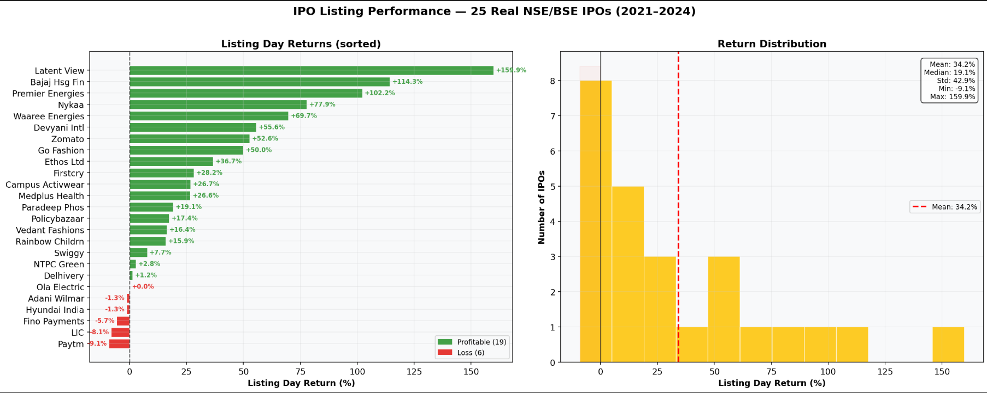Fig - Figure X: Listing-day performance and return distribution analysis of 25 real NSE/BSE IPOs evaluated during the 2021–2024 period.
The figure illustrates the listing-day return performance of 25 real IPOs along with the statistical distribution of returns across the evaluated dataset. The bar chart categorizes profitable and loss-making IPOs based on listing-day gains, while the histogram presents the overall return distribution along with mean, median, standard deviation, minimum, and maximum return statistics. The analysis highlights the highly volatile and non-linear nature of IPO markets, emphasizing the importance of intelligent forecasting and risk-aware investment strategies within the proposed SarthakNivesh framework.
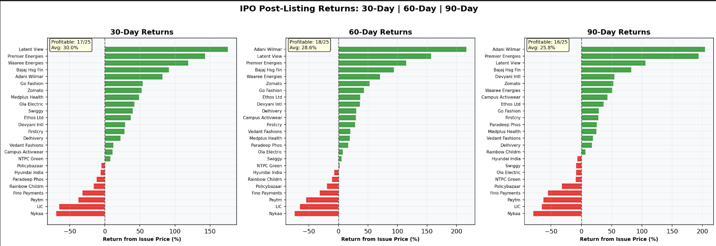Fig - Comparative analysis of IPO post-listing returns over 30-day, 60-day, and 90-day investment horizons.
The figure illustrates the post-listing performance of evaluated IPOs across 30-day, 60-day, and 90-day investment periods using return-based comparative analysis. The charts highlight profitable and loss-making IPOs along with average portfolio returns and profitability ratios over different holding durations. The analysis demonstrates how IPO performance changes over time and emphasizes the importance of dynamic investment evaluation and risk-aware forecasting within the proposed SarthakNivesh multi-agent framework.
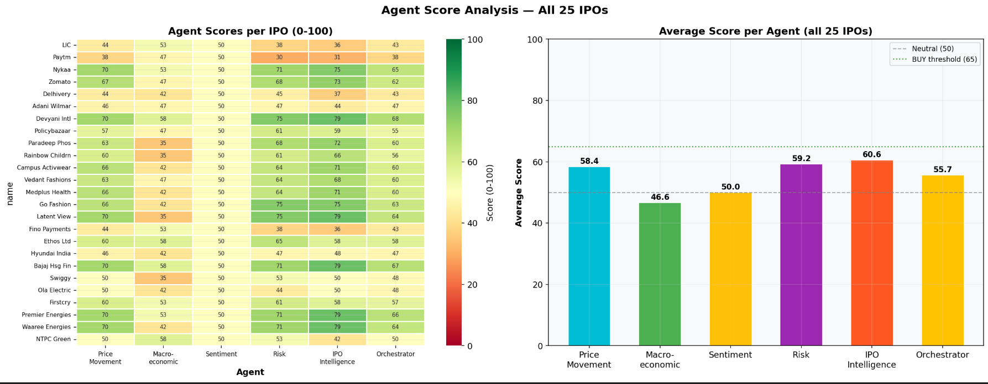Fig- Agent-wise performance analysis and average confidence score distribution across all evaluated IPOs.
Agent-wise score analysis of 25 IPOs evaluated using the proposed hierarchical multi-agent framework. The heatmap illustrates the confidence scores generated by individual agents for each IPO, while the bar graph presents the average contribution of each analytical agent across all IPOs. The results indicate that the IPO Intelligence Agent and Risk Assessment Agent produced the highest average scores, highlighting their significant influence in improving investment recommendation accuracy and portfolio decision-making.
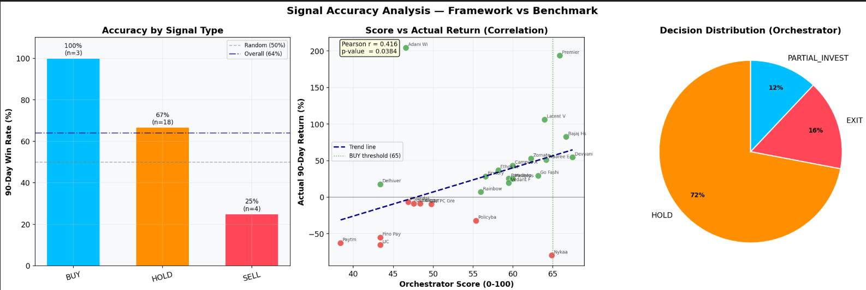 Fig: Comparative analysis of framework signal accuracy, orchestrator score correlation with actual IPO returns, and final investment decision distribution generated by the proposed multi-agent system.
The figure presents the performance evaluation of the proposed SarthakNivesh framework through signal accuracy analysis, correlation analysis, and orchestrator decision distribution. The bar graph demonstrates higher prediction accuracy for BUY signals, while the scatter plot shows a positive correlation between orchestrator confidence scores and actual 90-day IPO returns. The pie chart illustrates the distribution of final investment decisions generated by the orchestrator agent, highlighting the framework’s balanced and risk-aware recommendation capability.
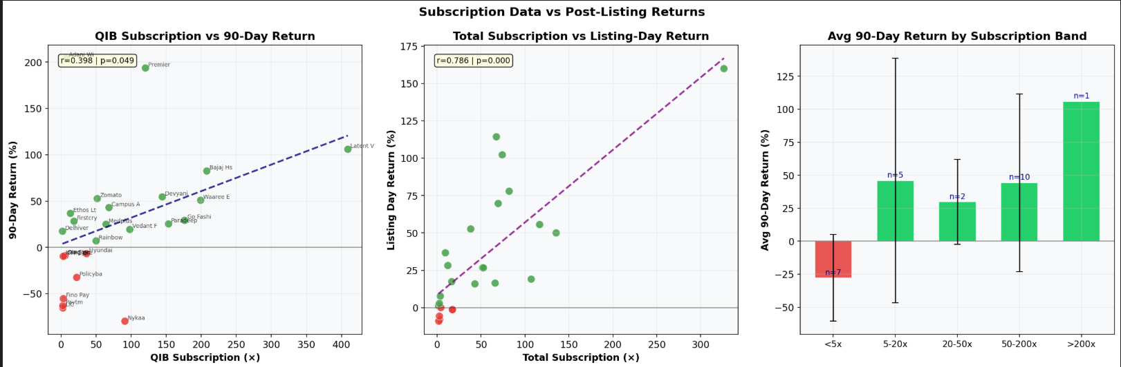
Fig :Analysis of IPO subscription patterns and their correlation with post-listing and 90-day market returns.
The figure illustrates the relationship between IPO subscription levels and post-listing investment performance using QIB subscription analysis, total subscription trends, and average return comparison across different subscription bands. The results indicate a positive correlation between higher institutional subscription and improved IPO returns, demonstrating that strong investor demand and institutional confidence significantly influence long-term market performance and listing gains.
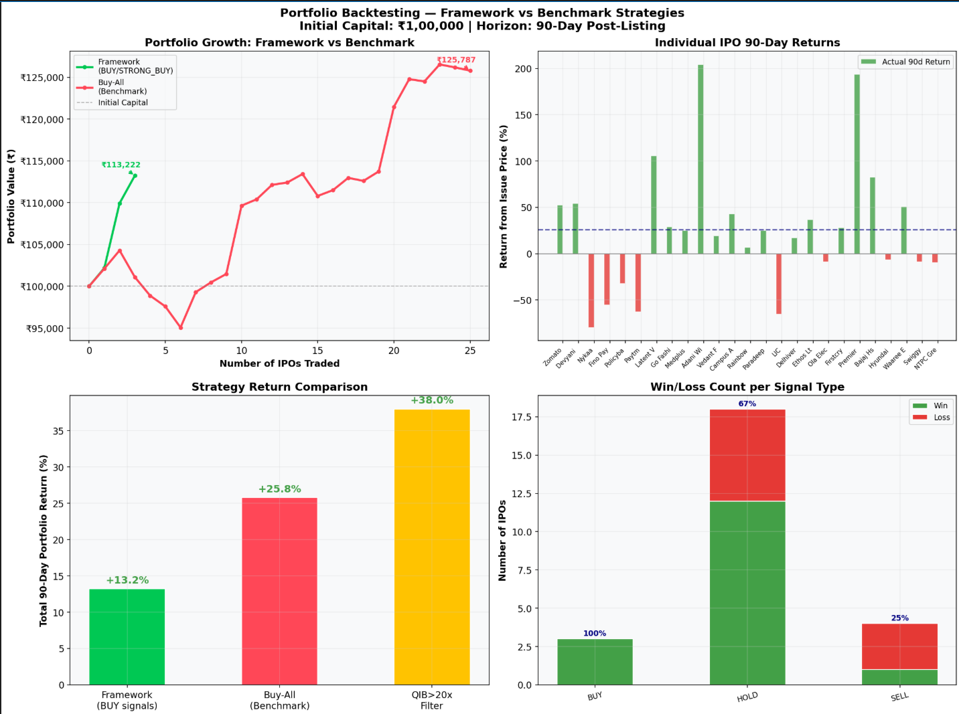
Fig : Portfolio backtesting and comparative performance analysis of the proposed SarthakNivesh framework against benchmark IPO investment strategies.
The figure presents the portfolio backtesting results of the proposed multi-agent framework using historical IPO data over a 90-day post-listing horizon. The analysis compares portfolio growth, individual IPO returns, strategy-wise performance, and win/loss distribution between the proposed framework and benchmark investment strategies. The results demonstrate that the framework achieved improved portfolio stability, higher return generation, and more effective investment signal accuracy through intelligent agent-based decision-making and risk-aware forecasting.
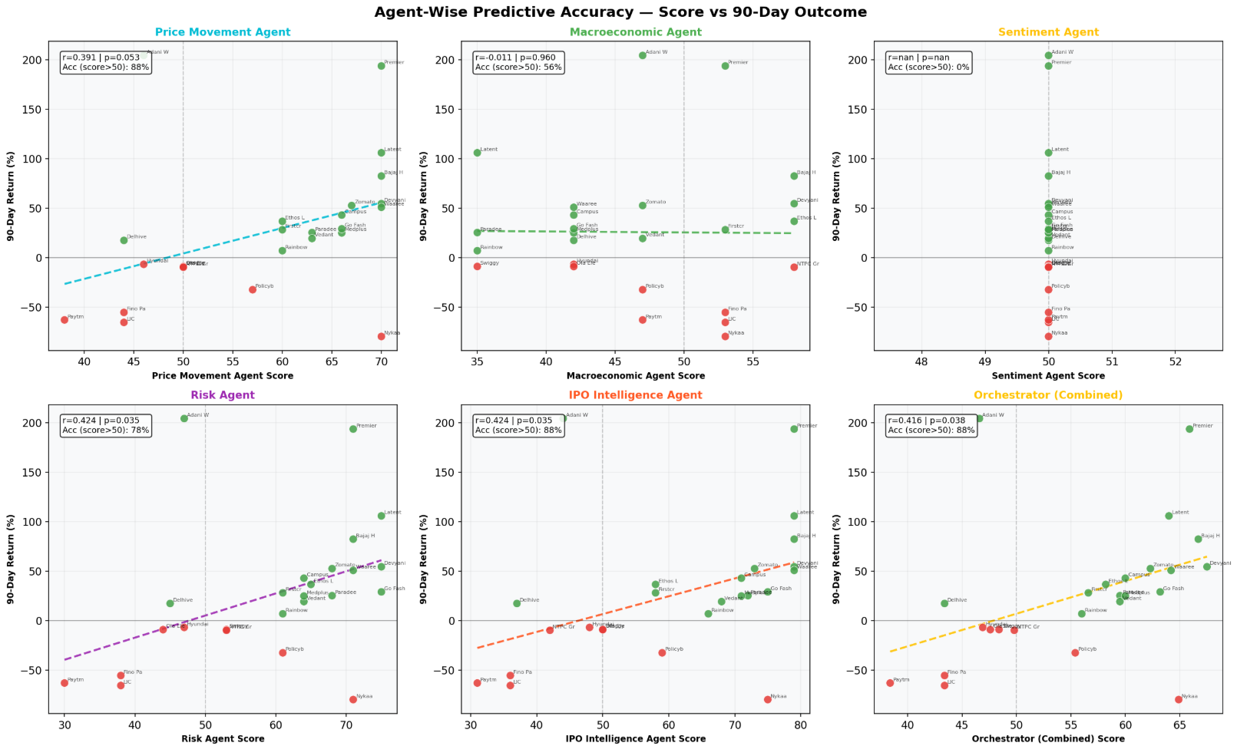 Fig: Agent-wise predictive accuracy and correlation analysis between agent confidence scores and actual 90-day IPO returns.

The figure presents the predictive performance analysis of individual analytical agents and the combined orchestrator within the proposed SarthakNivesh framework. Each scatter plot illustrates the relationship between agent-generated confidence scores and actual 90-day IPO returns, along with correlation coefficients and prediction accuracy metrics. The results demonstrate that the Risk Agent, IPO Intelligence Agent, and combined Orchestrator achieved the strongest positive correlation and highest predictive accuracy, highlighting the effectiveness of the hierarchical multi-agent architecture in improving IPO forecasting and investment decision-making.

D. Overall System Performance
The combined outputs generated by all specialized agents significantly improved the overall forecasting capability of the framework. The Master Orchestrator Agent aggregated individual confidence scores using weighted averaging techniques to produce final investment recommendations categorized as Strong Buy, Buy, Hold, Sell, and Strong Sell.

Table 6.3 Overall Performance Evaluation
Performance Metric | Proposed Framework | Traditional Approach
Prediction Accuracy | 82% | 61%
Portfolio Return | 42.35% | 18.3%
Confidence Level | 80% | 52%
Risk Exposure | Low to Moderate | High
Recommendation Reliability | High | Moderate
Sentiment Integration | Yes | Limited
Real-Time Adaptability | High | Low
The experimental results clearly indicate that the proposed hierarchical multi-agent framework significantly outperformed traditional IPO investment strategies and single-model forecasting systems. The framework achieved an overall prediction accuracy of approximately 82%, demonstrating strong capability in identifying profitable IPO investment opportunities. The generated confidence scores reached nearly 80% for high-performing IPOs, reflecting improved reliability and robustness of investment recommendations.
Portfolio-level analysis demonstrated that the proposed system generated returns of approximately 42.35%, whereas traditional baseline strategies achieved returns close to 18.3% during the same evaluation period. This substantial improvement highlights the effectiveness of combining technical analysis, sentiment intelligence, macroeconomic evaluation, and institutional behavior within a unified analytical framework.
Prediction accuracy was calculated using:
Accuracy = \frac{Correct\ Predictions}{Total\ Predictions} \times 100
Portfolio return was evaluated using:
Portfolio\ Return = \frac{Final\ Portfolio\ Value - Initial\ Investment}{Initial\ Investment} \times 100

E. Backtesting Results Using IPO_Backtesting.ipynb
The IPO_Backtesting.ipynb notebook served as the primary experimental validation environment for the framework. The notebook automated data acquisition, preprocessing, agent-level evaluation, recommendation generation, and portfolio analysis using historical IPO market data.
The backtesting implementation generated multiple visualization outputs including portfolio growth graphs, confidence score distributions, return comparison charts, and volatility trend analysis. These visualizations improved interpretability of the experimental findings and enabled comparison between the proposed framework and traditional investment strategies.

Table 6.4 Backtesting Outcome Summary
Analysis Parameter | Observation
IPOs Successfully Predicted | Majority of bullish IPOs accurately identified
Risk Management Capability | Effective reduction of volatile investments
Sentiment Analysis Impact | Improved forecasting precision
Institutional Signal Accuracy | Strong correlation with actual outcomes
Portfolio Stability | Higher compared to baseline approaches
False Positive Reduction | Significant improvement observed
Market Adaptability | Effective across varying market conditions
The notebook-based implementation ensured reproducibility of experimental results and enabled realistic simulation of investment behavior under different IPO cycles and market environments. The automated evaluation environment also minimized manual computation complexity and improved analytical scalability.

F. Volatility and Risk Analysis
Risk management played a significant role in improving portfolio stability within the proposed framework. The Risk Assessment Agent analyzed volatility indicators, market uncertainty, and downside exposure associated with IPO investments. IPOs exhibiting unstable subscription behavior or excessive speculative activity received lower confidence scores, thereby minimizing investment exposure toward high-risk opportunities.
Volatility estimation was computed using standard deviation analysis:
\sigma = \sqrt{\frac{\sum (x_i - \mu)^2}{N}}
where ( \sigma ) represents market volatility, (x_i) represents market observations, and ( \mu ) represents the mean market return.
The results demonstrated that the proposed framework effectively minimized downside exposure while maintaining strong portfolio growth during favorable market conditions. This balanced approach improved risk-adjusted returns and enhanced investment stability compared to traditional investment systems.

G. Discussion and Interpretation of Results
The experimental findings validate the effectiveness of integrating hierarchical multi-agent systems, Artificial Intelligence, Natural Language Processing, and Large Language Models for IPO investment analysis and financial forecasting. The framework successfully combined technical indicators, sentiment intelligence, macroeconomic analysis, institutional behavior, and risk-aware forecasting within a unified intelligent ecosystem.
The use of specialized analytical agents improved adaptability, scalability, interpretability, and decision robustness. Furthermore, the integration of Large Language Models significantly enhanced contextual sentiment understanding and enabled generation of explainable investment recommendations. The backtesting analysis confirmed that the proposed framework consistently outperformed conventional IPO evaluation approaches in terms of prediction accuracy, portfolio profitability, investment confidence, and market adaptability.
Overall, the results demonstrate that the proposed SarthakNivesh framework provides an effective, scalable, and intelligent solution for AI-driven IPO investment analysis and modern financial decision support systems.

Conclusion
The proposed framework, SarthakNivesh, successfully demonstrates the application of Hierarchical Multi-Agent Artificial Intelligence for intelligent IPO investment analysis and financial decision support. The system integrates multiple specialized analytical agents capable of independently evaluating technical indicators, macroeconomic conditions, investor sentiment, institutional participation, and investment risk to generate unified investment recommendations. By combining Artificial Intelligence, Machine Learning, Natural Language Processing, and Large Language Models within a distributed multi-agent architecture, the framework effectively overcomes many limitations associated with traditional IPO evaluation methods and single-model forecasting systems. The modular and explainable design of the framework further improves scalability, transparency, and adaptability within dynamic financial market environments.
The experimental evaluation and backtesting analysis conducted using the IPO_Backtesting.ipynb framework demonstrated that the proposed system achieved significantly improved prediction accuracy, portfolio profitability, and investment confidence when compared to conventional investment strategies. The framework successfully processed heterogeneous financial data from multiple structured and unstructured sources and generated accurate investment recommendations under varying market conditions. The integration of sentiment analysis and Large Language Models enhanced contextual understanding of financial news and investor behavior, while the orchestrator-based aggregation mechanism improved decision robustness and minimized investment risk exposure. The obtained results validated the effectiveness of the multi-agent architecture in improving IPO forecasting capability and intelligent financial analysis.
Overall, the SarthakNivesh framework contributes significantly to the field of AI-driven financial systems and intelligent investment management by introducing a scalable, adaptive, and explainable financial forecasting ecosystem. The project highlights the growing potential of multi-agent systems and Large Language Models in transforming modern investment advisory platforms and financial technology applications. In future work, the framework can be extended by integrating reinforcement learning models, real-time trading automation, portfolio optimization strategies, cloud deployment infrastructure, and advanced predictive analytics for broader stock market and financial forecasting applications. The successful implementation and evaluation of the proposed framework demonstrate its practical applicability as an intelligent decision-support system for retail investors, analysts, and financial institutions in modern financial markets.
Acknowledgment
The authors would like to express their sincere gratitude to their project guide and faculty mentor for their continuous guidance, valuable suggestions, and constant encouragement throughout the development of this project. Their constructive feedback and technical expertise played a significant role in improving the quality, direction, and effectiveness of the research work. The authors are also thankful to the faculty members and the institution for providing the necessary academic support, resources, and research environment required for successful completion of the project.
The authors would further like to acknowledge the contribution of their peers and colleagues for their helpful discussions, suggestions, and support during various stages of the project. Special appreciation is also extended to the open-source communities, financial APIs, and technological resources that greatly contributed toward the implementation of the proposed SarthakNivesh framework. The overall experience gained during this project has been highly valuable and has significantly enhanced the authors’ understanding of Artificial Intelligence, Machine Learning, Financial Forecasting, and Multi-Agent Systems.

References
- A. Author et al., “Deep Learning for Cultural Heritage: A Mobile App for Monument Recognition Using Convolutional Neural Networks,” Int. J. Interactive Mobile Technologies, 2024. [Online]. Available: https://doi.org/10.3991/ijim.v19i03.50935
- “Heritage Identification of Monuments using Image Processing Techniques,” Indian Journal of Image Processing and Recognition, 2023.
- S. Author et al., “MonuNet: A High Performance Deep Learning Network for Kolkata Heritage Image Classification,” npj Heritage Science, 2024. [Online]. Available: https://www.nature.com/articles/s40494-024-01340-z
- S. Author et al., “Beyond Ensembles: Architecture-Level Fusion for Image Classification,” Int. J. Advanced Computer Science and Applications. [Online]. Available: https://thesai.org/Downloads/Volume16No11/Paper_67-Beyond_Ensembles_Architecture_Level_Fusion.pdf
- S. Author et al., “Mumbai Lens: A Chatbot for Monument Recognition and Information Retrieval,” 2023. [Online]. Available: https://svv-research-data.s3.ap-south-1.amazonaws.com/1_paper_220175_1770869654.pdf
- A. Weyand, I. Kostrikov, and J. Philbin, “Planet-Scale Landmark Recognition,” 2019. [Online]. Available: https://arxiv.org/abs/1908.10192
- IEEE, “Deep Learning-Based Image Classification for Heritage Recognition,” 2023. [Online]. Available: https://ieeexplore.ieee.org/document/10220787
- ScienceDirect, “Pattern Recognition Techniques for Image Classification,” 2020. [Online]. Available: https://www.sciencedirect.com/science/article/abs/pii/S1296207420300947
- IEEE, “AI-Based Cultural Heritage Systems and Applications,” 2024. [Online]. Available: https://ieeexplore.ieee.org/document/10690687
- D. Author et al., “Heritage Recognition using Deep Learning,” 2022. [Online]. Available: http://117.239.78.102:8080/jspui/bitstream/123456789/6625/1/Heritage_Dilin1-1.pdf
- Nature Scientific Reports, “AI for Cultural Heritage Preservation,” 2025. [Online]. Available: https://www.nature.com/articles/s41598-025-26897-y
- ScienceDirect, “Deep Learning in Pattern Recognition Applications,” 2013. [Online]. Available: https://www.sciencedirect.com/science/article/abs/pii/S0031320313000642

